**MAIN FRAME**

A mainframe is a **large, powerful computer used by large organizations for critical applications that require high levels of security and reliability**.

It can connect to multiple end clients simultaneously so that several users can access different applications and processes running on the mainframe concurrently without impacting performance or security.

Mainframes are often used for:

* **Data processing:** Mainframes are used for bulk data processing, such as censuses, industry and consumer statistics, and enterprise resource planning.
* **Transaction processing:** Mainframes are used for large-scale transaction processing and can process up to one trillion web transactions daily.
* **Commercial databases:** Mainframes are critical to commercial databases and transaction servers.

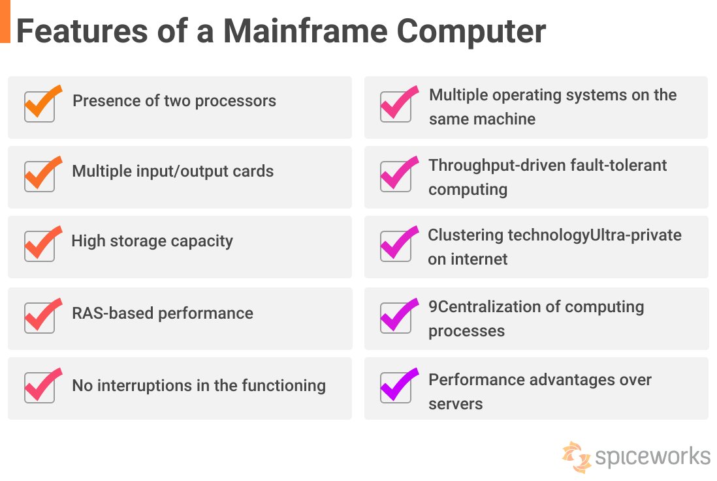

Mainframes are known for their security and reliability, and are often the central data repository in a corporation's data processing center. They are linked to users through less powerful devices such as workstations or terminals.

The term "mainframe" originally referred to the large cabinet that held the central processing unit (CPU) of early computer systems

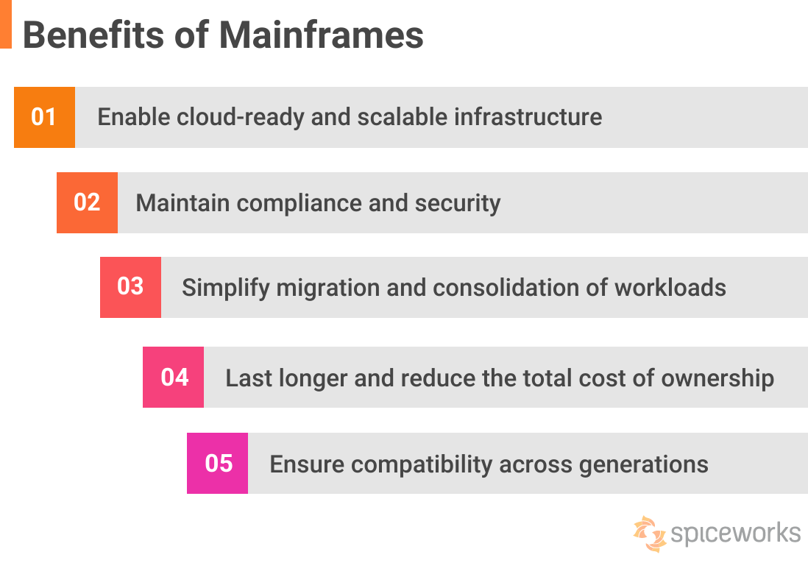

[](https://www.spiceworks.com/user/about/chiradeepbasumallick) [Chiradeep BasuMallick](https://www.spiceworks.com/user/about/chiradeepbasumallick) Technical Writer

January 19, 2023

A mainframe is defined as a large, powerful computer typically used for complex calculations and data processing tasks. It can connect to multiple end clients simultaneously so that several users can access different applications and processes running on the mainframe concurrently without impacting performance or security. This article explains how mainframes work and discusses their importance, even in the age of cloud computing.

**Table of Contents**

* [What Is a Mainframe?](https://www.spiceworks.com/tech/tech-101/articles/what-is-mainframe/#_001)
* [Features of a Mainframe Computer](https://www.spiceworks.com/tech/tech-101/articles/what-is-mainframe/#_002)
* [Why Are Mainframes Important?](https://www.spiceworks.com/tech/tech-101/articles/what-is-mainframe/#_003)
* [Examples of Mainframes](https://www.spiceworks.com/tech/tech-101/articles/what-is-mainframe/#_004)

What Is a Mainframe?

A mainframe computer, often colloquially known as a big iron or mainframe, is typically used by large enterprises for mission-critical applications. This involves processing massive amounts of data for activities like censuses, industry and consumer analytics, enterprise resource planning, or large transaction processing. Today’s mainframes are far smaller than the “Big Iron” giants of the past. The most recent mainframe might cohabit with various systems in the data center using a 19-inch rack.

Modern mainframes are also referred to as data servers (even though servers are not identical to mainframes). This is because they are meant to execute up to 1 trillion daily online transactions with the highest degrees of safety and dependability. In practice, mainframes have a high degree of availability, as they are frequently used for applications in which downtimes would be expensive and, at times, challenging for an organization.

Reliability, availability, and serviceability or RAS, is the distinguishing feature of mainframe computers. Other primary features include:

* Mainframes may boost or modify system capacity on the go without interrupting system operations. Its precision and granularity offer expertise and sophistication uncommon amongst server solutions.
* Modern mainframes, such as the IBM zSeries, provide two [virtualization](https://www.spiceworks.com/tech/cloud/articles/virtualization-in-cloud/) levels: logical partitions and virtual machines. Many mainframe users maintain two machines: one at their primary data center and the other in their backup data center, which may be fully active, partly active, or in standby mode in the event of a disaster affecting the primary data center.
* Testing, developing, training and production workloads for applications and databases may work on a single system unless the demand is exceedingly high and the machine’s capacity is exhausted. This configuration of two mainframes may enable continuous business service, preventing both planned and unscheduled interruptions.
* Mainframes are intended to manage very large input and output (I/O) volumes and prioritize throughput. Ever since the 1950s, mainframe architectures have included auxiliary hardware to control I/O devices, freeing the CPU to focus solely on high-speed memory.
* It is typical for mainframes to administer enormous databases and files. Records of gigabyte to terabyte-size capacity are quite common. Mainframes often contain enormous volumes of online data repositories compared to a regular PC and can also be accessed rapidly.

Evolution of mainframe computers

From the 1950s to the early twenty-first century, many manufacturers and their successors built mainframe computers, with the number steadily decreasing as the cloud matured. The 700/7000 series and subsequent production of the 360 series mainframes led to IBM’s unquestionable ascendancy. Their present zSeries mainframe computers have continued to advance from the later design.

Germany’s Siemens and Telefunken, U.K.’s ICL, and Japan’s Fujitsu and Hitachi were notable foreign manufacturers. During the Cold War, the Soviet Union and Warsaw Pact nations produced indistinguishable clones of IBM mainframes.

In the 1980s, minicomputer-led systems became increasingly advanced and were able to replace the lower portions of the mainframes. And over the next few decades, businesses discovered that servers built on microcomputer designs could be implemented for a fraction of the purchase cost and offer local users far more autonomy over their own systems, given the then-current IT policies and practices.

Personal computers progressively replaced the terminals used for communicating with mainframe systems. As a result, demand decreased, and future mainframe installations were mainly limited to the financial sector and the government.

IBM unveiled their most recent mainframe system, the IBM z16, in April 2022, which had an on-chip [artificial intelligence (AI)](https://www.spiceworks.com/tech/artificial-intelligence/articles/what-is-artificial-intelligence/)accelerator and a new CPU, giving mainframes a fresh lease on life.

What do mainframes do?

Mainframes carry out three essential tasks. Let’s understand each one in detail.

* **Act as a data warehouse orchestration system**: Every computer has a hard drive for long-term data storage, but mainframe systems store the entire data as an application inside themselves. When remote users with linked terminals attempt to log in, the mainframe grants all remote terminals access to their files and applications.
* **Help enforce authentication and access permissions**: Storing data and software files on a single mainframe system may increase efficiency, but it may also jeopardize data security. In mainframe systems, administrators have control over programs and data. They can also determine the individuals who have access. Therefore, mainframes may serve as firewalls against intruder attacks.
* **Allocate processor time and resources**: Mainframe systems can divide a finite amount of processing power among all concurrently logged-in users. Consequently, the mainframe determines which types of priority correlate to which types of users. The mainframe administrator has the authority to determine these priorities and allot processor resources.

**See More:** [**What Is Web Real-Time Communication (WebRTC)? Definition, Design, Importance, and Examples**](https://www.spiceworks.com/collaboration/unified-communications/articles/what-is-webrtc/)

Features of a Mainframe Computer

A mainframe computer offers the following features.

**Features of a Mainframe Computer**

1. Presence of two processors

There are two types of processors in mainframe computers: the primary processor and the system assistance processor, or SAP. The latter doesn’t process data but transfers it from one location to another as quickly as possible. Each CPU may contain up to seven to ten specifically-built and constructed cores for increased throughput.

2. Multiple input/output (I/O) cards

Each mainframe may contain as many as 160 I/O cards because they are designed for redundancy. This means that if one card malfunctions, others will take up its tasks until it is replaced.

3. High storage capacity

These systems have tremendous storage capacity, allowing them to process massive volumes of data on demand. It can store a vast quantity of data and interpret it according to user specifications. After data processing, the system can provide accurate findings with zero data inaccuracies.

4. RAS-based performance

All applications on mainframes are designed with reliability, availability, and serviceability (RAS) in mind, which distinguishes the machine from other systems. With the aid of these computers, data processing is simple, and businesses use the scalability characteristic of the system to work with varying storage capacities. The CPUs within the system sustain the computational power of all of these apps.

5. No interruptions in the functioning

When updating software on a mainframe, workloads are distributed across the processors so that productivity is not hindered. In other cases, pausing the system might be prohibitively expensive for the business. If the organization is a financial institution, it could even endanger national security because of the inability to process applications. The primary function of mainframes is to make important systems accessible around the clock.

6. Multiple operating systems on the same machine

Multiple operating systems may be hosted on a particular mainframe. For instance, it is typical to utilize z/OS alongside [Linux](https://www.spiceworks.com/it-security/network-security/articles/top-10-linux-firewall-solutions/) on a single mainframe. z/VM, z/VSE, Linux for System z, and z/TPF are the four dominant operating systems for mainframes, along with z/OS.

7. Throughput-driven fault-tolerant computing

A substantial quantity of output and input data is sent to the system. This means that mainframes must be able to manage all of this data, applications, and processes with ease. The quantity of data transported to or from a system does not affect mainframes. In addition, the mainframe ensures no errors occur while moving massive volumes of data inside its database. This feature is known as fault-tolerant computing.

8. Clustering technology

Mainframe systems support clustering technologies with close coupling (called Parallel Sysplex in an IBM environment). This capability enables the operation of up to 32 machines as a unified system configuration. Even if a system crashes, work will be completed seamlessly on the subsequent live system with no performance loss.

9. Centralization of computing processes

The mainframe system centralizes the administration of computing tasks. This implies that all activities occur in the mainframe’s processing section, and the results are shown on a client’s desktop monitor. The user may interact with an application or utility operating on the desktop while the mainframe operates in the background.

10. A move towards flexibility

Today, however, the difference between centralized and distributed computing is rapidly diminishing. Consequently, mainframes are routinely combined with clusters of simpler servers in a range of topologies. Modern mainframe hardware and software assets (like processors, storage, and device interfaces) may be reconfigured dynamically while programs continue to operate. This highlights the adaptable and evolving nature of modern mainframes.

11. Performance advantages over servers

The properties of mainframes must be comprehended in relation to servers and their intrinsic differences. Although the words are often used interchangeably, mainframes and servers are unique in the following ways:

* **Size**: Physically, a standard commodity server is smaller in size than any mainframe. This is not due to the scale of mainframe computers. These days, mainframe computers are roughly the equivalent of a refrigerator. However, a server tray of the same size might accommodate around 12 low-cost servers. Mainframes will most certainly be bulkier than conventional servers due to the computing hardware resources it contains.
* **Throughput**: If a standard server can process 300 transactions per second, this translates to around 26 million transactions each day. This is a substantial figure, but it pales compared to the trillions a mainframe can manage. IBM claims that Z13 mainframes can process 2.5 billion daily transactions.
* **Versatility**: It is not possible to migrate mainframe workloads to commodity servers. However, you may shift tasks to a mainframe that would ordinarily be executed on a commodity server. What this means is that mainframes offer the best of both worlds. Users can access mission-critical applications that cannot operate elsewhere and manage server workloads on commodity hardware.

**See More:**[**Top 10 Antivirus Software in 2022**](https://www.spiceworks.com/it-security/network-security/articles/best-antivirus-software/)

Top 6 Benefits of Mainframes

Nowadays, mainframe computers play an essential role in the everyday operations of most of the world’s top enterprises, including Fortune 1000 corporations. Despite developments in other forms of computing, mainframes remain significant in finance, banking, medical services, insurance, utility, administration, and many other private and public sectors.



**Benefits of Mainframes**

1. **Enable cloud-ready and scalable infrastructure**

For cloud deployment, mainframes enable a range of highly secure virtualized environments. This comprises the z/VM operating system, blade servers, hypervisors, as well as logical partitions (LPARs).

* In addition to supporting millions of users with greater speed, mainframes are the best platform for big data analytics, data management, and web applications. Consequently, the technology is highly scalable.

2. **Maintain compliance and security**

Mainframes support industry standards, compliance regulations, and best practices with the help of data encryption, role segregation, privileged user monitoring, secure communication systems, audit reporting, and other mechanisms.

It provides enterprise-wide visibility and a high degree of security transparency, enabling improved control. In addition, private clouds built on mainframes may reduce the inherent security risks of [public cloud](https://www.spiceworks.com/tech/cloud/articles/what-is-public-cloud/) services with open networks.

3. **Simplify the migration and consolidation of workloads**

Transferring dispersed tasks to the mainframe setup is simple. This decreases the number of distributed systems that must be controlled. When your virtual environment has been optimized, it is simple to consolidate various tasks on the mainframe while maintaining the necessary separation between systems. This also minimizes the license expenses that dispersed systems would incur.

4. **Reduce the total cost of ownership**

The biggest benefit of mainframe computers is their unparalleled longevity. These computers have an average lifetime of over ten years. Until that point, mainframe computers are often problem-free. Once the average lifetime has been achieved, consumers can choose between replacing or upgrading the unit.

In addition, there is a threshold at which increasing server numbers becomes more expensive than operating the workload on a mainframe. [Research on security managementOpens a new window](https://securityintelligence.com/9-advantages-to-mainframe-for-cloud-computing/) determined that the total cost of ownership (TCO) over three years for a private cloud built on IBM zEnterprise systems was 76% lower than for a public cloud offered by a third-party service provider.

5. **Ensure compatibility across generations**

The operating system for mainframe computers supports a vast array of software and hardware. However, a mainframe will support most software, irrespective of the OS version. Even after an update, the system is still capable of running legacy programs. In addition, mainframe computers don’t limit the number of concurrent operating systems. Multiple operating systems can be created to function, thereby enhancing the system’s overall performance.

6. **Compatible with blockchain technology**

[Blockchain](https://www.spiceworks.com/tech/devops/articles/what-is-blockchain/) is among the most fascinating new applications for which mainframes are an ideal match. In terms of reaction speed, transaction throughput, scalability, or security, the mainframe is the perfect blockchain host over x86 servers.

Additionally, its security advantage is a decisive advantage. The blockchain approach is predicated on transaction data carried in a network of immutable data blocks that cannot be altered once assembled. Mainframes can deliver 100% encryption without affecting performance due to their higher computing capability.

While mainframes remain essential for the reasons mentioned above, **they also have a few drawbacks**. Before setting up a mainframe computer system, one should examine the following: